 | Parks & Recreation Commission  Neenah City Hall – Hauser Room  211 Walnut Street  Neenah, WI 54956 | 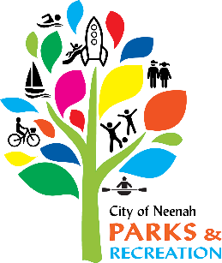
NOTICE OF CANCELLATION

PARKS & RECREATION

COMMISSION MEETING
Thursday, January 16, 2025

The Parks & Recreation Commission meeting scheduled for Thursday, January 16, 2025 has been canceled.

Creating Community Through People, Parks & Programs

